Catherine Toms, English Teacher, Featherstone High School

“If I develop a series of questions with Year 11 students which allow them to interrogate texts, will it improve their analysis?”

Stimulus
The stimulus for this research has been our whole school development focus on literacy as stated in our School Development Plan to ensure “improved delivery of literacy skills across the curriculum” (SDP 2010/11). Plus analysis of data available (such as Controlled Assessment grades in reading versus writing) regarding the attainment of our students at GCSE, suggests that their reading skills are considerably weaker than their writing skills in general.
In addition, the Framework for Secondary English written in 2008 states that ‘Pupils will engage with, and respond to, a rich variety of print, electronic and multi-modal texts, developing analysis and awareness of the forms and purposes of writing, and the contexts and cultures within which they were written.’ This specific reference to “developing analysis” is, I believe, the key to students being able to unlock their appreciation of and engagement with the written word and the hope was that we could develop a way of working which would lead to this “unlocking”.

Therefore, in discussion with Carole Verity (Secondary English Consultant at LB Ealing), it was decided that it would be beneficial to develop a set of questions that would guide and support students in their analysis of texts, allowing them to move towards a more independent examination of reading materials. At KS3 teachers and students use specific reading assessment foci to guide students in what they should be looking for in reading texts and these are also used to formatively assess our students’ progress. Therefore it was felt that using these foci as the basis for developing a set of questions that students can ask of the texts they are reading would enable KS4 students to improve and deepen their understanding.
Dan Kurland – author of a website on critical reading - suggests that in order to fully understand a text we need to ask questions of it. Students in the early years of their learning are taught to scan, skim and close read but “they are not told what to look for and how to think about what they find. They are not told about how language is used to communicate ideas.”
Therefore my research was primarily undertaken in order to allow students to understand what they should be looking for when they are reading; how ideas are conveyed in writing; and ensure that as they read they are able to draw meaning from the writing. In summary giving students a way to gain closer understanding of the texts they are reading by ensuring they understand “how to question, what to look for when they read, and how to find the meaning” (Dan Kurland).

Literature review
In my research into this topic, I referred to previous Action Research reports in this programme – one written by Andrea Hetherington, Literacy Leader and Jessica Humphries, KS4 Leader, of Greenford High School whereby they addressed the issue of “What strategies can teachers use to help low ability learners become active and engaged readers?” In their research they found that the following approach was effective in English, “The use of stepped questioning. At first, specific questions used to guide students, but with each step questions had less scaffolding.” This research helped to guide me in the development of my research in action project.
In addition, Nadia Habraszewski of Featherstone High School conducted her research in 2010 and 2011 into “thinking frame models” and how they “develop thinking skills”. Her conclusions were that providing some sort of thinking frame promoted, “a movement away from superficial forms of learning and a move towards deeper learning of more value long term, through developing the students’ ability to think.” This approach of enabling pupils to explain how or why I felt would be a key part of my practical enquiry.
Furthermore the report “Teaching for progression: Reading” published in 2008 by the Department for Children, Schools and Families was influential in supporting the ideas which formed the basis of my enquiry. For instance the report states that “The main reading strategies which develop efficient reading and focus on the important features of a text are: asking questions of the text.”

Hypothesis and Impact Measures
In teaching reading, one key pedagogical approach is “the explicit teaching and demonstration of active reading strategies, presented to pupils as a reading ‘toolkit’ which they are able to access increasingly independently as they interact with texts.” (Page 2, “Teaching for Progression: Reading”, DFCS). This thinking led me to work with my students to develop just such a “toolkit” in the hope that a “set of questions would allow them to interrogate the texts and develop their analysis skills”.

The impact measures that I would be using would be a comparison between their first and second attempts at the GCSE controlled assessments which are designed to assess their reading skills. My two year 11 classes were undertaking slightly different GCSEs in English whereby the controlled assessments they needed to complete were slightly different – for English, they complete three reading assessments on Poetry, Drama and Prose and for English Language, only one extended reading assignment on a piece of prose.

In their first attempts at these controlled assessments, completed up to December 2011, many of the students fell short of the mark they needed in order to achieve their target grade. Therefore the production and marking of a second attempt, after the introduction of the questions “toolkit” developed as part of this enquiry, would be the ideal opportunity to assess the impact of this approach to reading.

Strategy/Methodology
At KS3 teachers use the Assessing Pupils Progress (APP) grids to frame their teaching and guide and monitor the learning of their pupils. These are as follows:
AF2: Understand, describe, select or retrieve information, events or ideas from texts and use quotation and reference to the text.
AF3: Deduce, infer or interpret information, events or ideas from texts.
AF4: Identify and comment on structure and organisation.
AF5: Explain and comment on writer’s use of language, including grammatical and presentational features at text level.
AF6: Identify and comment on writers’ purpose and viewpoints and the overall effect of the text on the reader.
AF7: Relate texts to their social, cultural and historical contexts and literary traditions.
These Assessment Foci were fully discussed with my year 11 pupils and their meaning agreed. Each Assessment Foci was then used to create a number of questions with which to interrogate texts and meet that focus. The helpful by-product of this approach was to create a set of questions which can be utilised at KS3 in order to provide a coherent and structured approach for students to understand how to meet each Assessment Focus. However at GCSE, their assessment foci are more condensed so then we needed to transfer the questions we developed so that they corresponded to the KS4 Assessment Objectives.

For English Language the Assessment Objectives are:

And for English the Assessment Objectives are slightly different, with the inclusion of a requirement to show understanding of texts in their context:

Below are each of the KS4 Assessment Objectives and the bank of questions we agreed on which would help the students address each of these objectives in their assessments.
Read and understand texts/selection of material appropriate for purpose.
Questions to ask of the text:
- Why does the writer use this title?
- Find a quotation to support the view that...?
- Which sentence in this paragraph makes the main point?
- What are the most important pieces of information in this section/chapter/paragraph?
- What does… mean?
- Can.... have more than one meaning?
- What happened at (this point in the text e.g. beginning etc)?
- What did… (character) do?
- Which word told you that ……?
- What happened to...?
- Describe...?
- Which paragraph tells you that...?
- Where are...?
- Why do...?

Develop and sustain interpretations of writers’ ideas and perceptions.
Questions to ask of the text:
- How did...?
- What words tell us ...?
- Why did...?
- What does the word... imply about...?
- What ideas are we given about...?
- What does ... think?
- How did... react to...?
- What feelings does the writer want you to have about the events in this text?
- Does the author like...? How do you know?
- What can you tell about the viewpoint of the author?
- Who is likely to buy this book? Why?
- Why were ... included?
- How did you feel when reading this text?
- What narrative viewpoint does the text have? What effect does this have on the reader?
- What questions would you ask of the writer? What do you think their response would be?
- How was... different/same after...?
- Why is... important?
- Who does the writer sympathise with? How do you know?
- What evidence can you find to support the view that...?

Explain and evaluate how writers use linguistic, grammatical, structural and presentational features to achieve effects and engage and influence the audience.
Questions to ask of the text:
- What is the purpose of...?
- How does the layout help to...?
- Why did the writer choose to...?
- Why does the writer use...?
- Can you give each section/paragraph a subtitle?
- How is the whole text structured?
- How are links made between/within paragraphs?
- Why does the writer compare... to...?
- What does... tell you about...?
- Why did the writer use this (e.g. simile)?
- How does... help you to understand?
- How has the choice of words here helped with the feeling of...?
- What do phrases such as... tell you?
- Why did the writer choose the verbs/adjectives/punctuation at this point in the text?
- What is the effect of the language technique (onomatopoeia/personification etc) ?
- How does the writer achieve ... tone?

Understand texts in their social, cultural and historical contexts.
Questions to ask of the text:
- Which genre best describes this story? Explain using evidence from the text.
- What type of text is this? How do you know this?
- How do we know this writing is from (e.g. this century)
- What words tell you that this story is from ... era?
- What comment on society is the writer making in this text?
- What words/phrases tell you that this text is written about x country ... culture?

These questions were then laminated and a set of the questions addressing each Assessment Objective made for each of the students to guide them in their analysis of texts. These sets of questions were then used depending on the lesson objective – for instance if the lesson objective was “How does Steinbeck use language to shape meanings when presenting Lennie” then the set of questions on “Explain and evaluate how writers use linguistic, grammatical, structural and presentational features to achieve effects and engage and influence the audience” would be used. All sets of questions were used at different points during the scheme of work. Another example of the questions being used for a different objective – “How does the reader link the text to the context in Romeo and Juliet” - for this objective, the questions regarding “Understand texts in their social, cultural and historical contexts” were used to support the students’ learning.

Initially, I wanted to prepare a set of questions for addressing non-fiction texts also, however time constraints mitigated against this.

The first stage of my enquiry was to have a piece of text on the whiteboard and then model and annotate how to use the questions to interrogate the text. As the Secondary National Strategies document, “Reading for Progression” states, “Using a shared text to model the way the readers think and ask questions as they read” is good practice.
This was then followed with the students working in pairs to use the questions themselves to ask questions of a different part of the text. In later lessons, students were put into groups and asked to use the questions more as a support mechanism to refer to if they needed guidance in any way. At this point, especially the more able students, were independently asking the agreed questions of the texts plus their own additional and searching questions.

The resulting analysis produced by the students in the early stages of my enquiry was certainly improved especially in areas such as context and authorial viewpoint. However their analysis of the effects of language at word and sentence level were still limited. With this in mind, I found the “Reflecting on Reading” mats produced by the Hertfordshire Grid For Learning (an example of which is below) which provided the students with the scaffolding/modelling help they required with how to explain the effects of aspects such as language/structural devices.

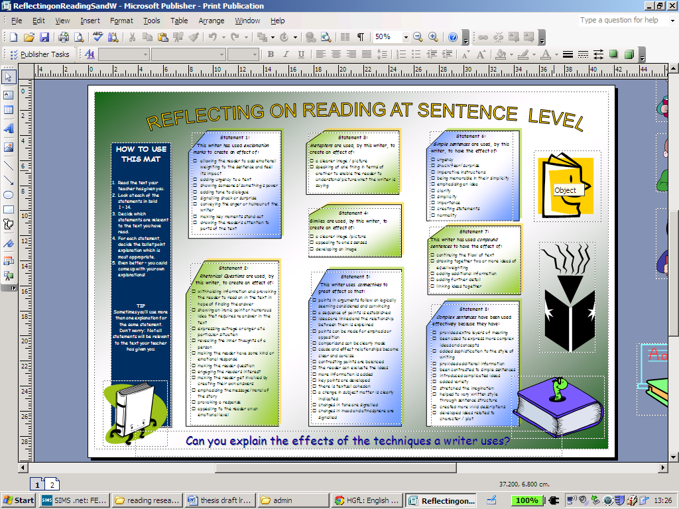

Findings
After using the questions toolkit plus the reflecting on reading mats the reading controlled assessments of my students ALL improved. In my year 11 class taking English, their results improved slightly (Class A), mostly moving up one Band (or grade) level and in my year 11 class (Class B) which took English Language GCSE – their results improved dramatically, mostly moving up 2 Bands (or grade) levels. The tables below chart their progress.

Class A
All controlled assessments are out of 15:

Student | Prose (before research project) | Prose  (after research project) | Drama (before research project) | Drama(after research project) | Poetry(before research project) | Poetry(after research project)
A | 9 | 10 | 9 | 11 | 9 | 10
B | 9 | 11 | 9 | 11 | 8 | 10
C | 8 | 10 | 8 | 10 | 7 | 10
D | 7 | 9 | 9 | 11 | 8 | 10
E | 9 | 11 | 9 | 10 | 8 | 12
F | 8 | 10 | 9 | 10 | 8 | 10
G | 8 | 10 | 8 | 10 | 8 | 9
H | 7 | 9 | 8 | 10 | 8 | 11

Class B
This class took the English Language route as they also studied for English Literature. In this GCSE there is only one controlled assessment assessing their reading skills – the unit called Understanding Written Texts (extended reading). Prior to introducing the range of questions decided upon to interrogate aspects of a text their marks (out of 30) were very disappointing with a marked lack of depth of perception in their language analysis and low levels of original interpretation of the text. Below is a selection of 8 students showing their mark (out of 30) before using the questions and their mark after redoing their controlled assessment having used the support of our questions to guide their interrogation of the text.

Student | Extended reading(before research project) | Extended reading(after research project)
I | 12 | 22
J | 14 | 24
K | 12 | 21
L | 12 | 22
M | 6 | 16
N | 12 | 24
O | 15 | 20
P | 16 | 23

In trying to ascertain the impact of this approach to teaching reading, I also interviewed students to find out how helpful, or otherwise, they felt the use of the questions to be. Their responses included, “I learnt everything in more depth using the questions and felt more confident doing the controlled assessments.”; “The questions really helped me to analyse how writers use language for effect.”; “When I was trying to meet the Assessment Objectives and improve my reading analysis the questions helped to break things down into smaller chunks which I could understand better.” “Things got better when we worked in small groups just looking at the questions occasionally when we got stuck on how to analyse what we were reading.”
Discussion of Findings
It can be deduced from the improved results after the students used the agreed questions as a basis to analyse the texts they were studying that this support mechanism did indeed improve their analysis. However the students were also two thirds of the way through their GCSE and therefore when retaking their controlled assessments there had naturally been development and progression in their reading skills due to a consistent teaching and learning approach designed to impact significantly on their progress. In addition their previous assessments had been formatively marked with targets for how to improve.

However, due to the significant level of their progress – especially the higher achieving students who were able to quickly develop an independent approach to their learning - I do believe that the questions had a significant impact on their progress and understanding.

Recommendations and Next steps
The use of this approach to support reading analysis is definitely an approach I would recommend at both KS3 and GCSE level and I will be discussing my findings with my department. In addition, I will be using this approach to develop a separate set of questions which will allow my students to interrogate non-fiction texts in a similar way and developing a set of differentiated questions for different levels of abilities.

Reading/References
Watkins, C., Carnell, E. and Lodge, C. (2007) ‘What is Effective Learning in Classrooms?’ Sage: London.

DfES (2005) Improving Reading: A department handbook, Crown Copyright: London

DfES (2009) Improving Readers: a handbook for improving reading in key stages 3 and 4, Crown Copyright: London.

LB Ealing (2011) “What strategies can teachers use to help low ability learners become active and engaged readers?” Andrea Hetherington and Jessica Humphries, Ealing Lead Research Practitioner Programme, Action Research

LB Ealing (2011) “To what extent can Thinking Frame Scaffolds develop thinking skills and raise attainment in science?” Nadia Habraszewski, Ealing Lead Research Practitioner programme, Action Research

DFES (2008) Framework for secondary English, Crown Copyright: London

www.criticalreading.com/linguistic_approach.htm

